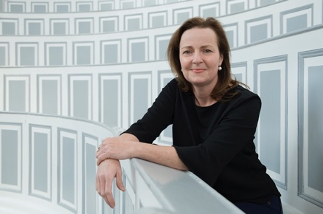
Professor Heike Kielstein, MD

Date & place of birth 01/14/1970, in Hannover
Current position Director, Institute for Anatomy and Cell Biology
Head of Clinical Anatomy
Director of the Meckel Collections

1989-1996 Study of medicine
Hannover Medical School, Hannover, Germany & CHU der Rennes, France

1996-2007 Postdoctoral Research Fellow
Institute of Functional and Applied Anatomy, Hannover Medical School, Germany

2007-2011 Junior Professor for Neuro-Endocrine-Immune-Interactions
Hannover Medical School, Hannover, Germany

2011-2016 Assistant Professor for Anatomy
Martin Luther University, Halle (Saale), Germany

since 2016 Full Professor and Director of the Institute for Anatomy and Cell Biology
Martin Luther University Halle-Wittenberg, Halle (Saale), Germany

Honors & Awards
Member of the Saxon Academy of Sciences and Humanities
Professor of the year (2017, for Medicine & Sciences in Germany)
Teacher of the year (2012 & 2015, Martin Luther University Halle-Wittenberg)
Teacher of the year (2001 & 2009, Hannover Medical School)
Ernst Eickhoff-Prize for Endocrinology (2008)

Main scientific interest
In-vivo and in-vitro investigations of altered immune functions in obesity

Review activities

Member of the editorial board of Annals of Anatomy

Reviewer for journals in the field of Endocrinology, Immunology and Anatomy
Reviewer for national and international grants

More than 50 MD-, PhD- and Master-students

Committee work
Senator of the Martin Luther University Halle-Wittenberg
Member of the Faculty Board of the Medical Faculty of the Martin Luther University Halle-Wittenberg
Member of various committees of the Medical Faculty (e.g. teaching committee)
Member of the Executive Board of the medical Graduate School HaPKoM

Director of the University Advisory Board of the Protestant Church in Central Germany

Member of the Supervisory Board of the ‘Evangelisches Studienwerk’

Liaison lecturer of the ‘Evangelisches Studienwerk’

Mentor in various local and national mentoring programs

President of the European Union of friends of Henry van de Velde

Mentorin im verschiedenen Mentoring-Programmen, u.a. MLU Mentoring Programm; Mentoring-Programm für Postdoktorandinnen des Universitätsbundes Halle – Jena – Leipzig; Projekt MeCoSa 4.0 (Mentoring- und Coaching Programm des Landes Sachsen-Anhalt)

